Career page
In the navbar we are showing the career module

Whenever I click on the career in the navbar we are getting the what are the openings/vacancies related to that company like
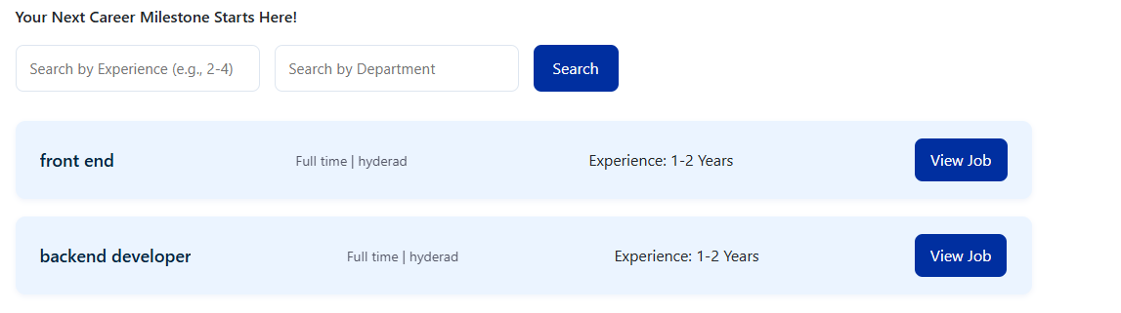

Whenever I click on the view job button we need to display that particular job details
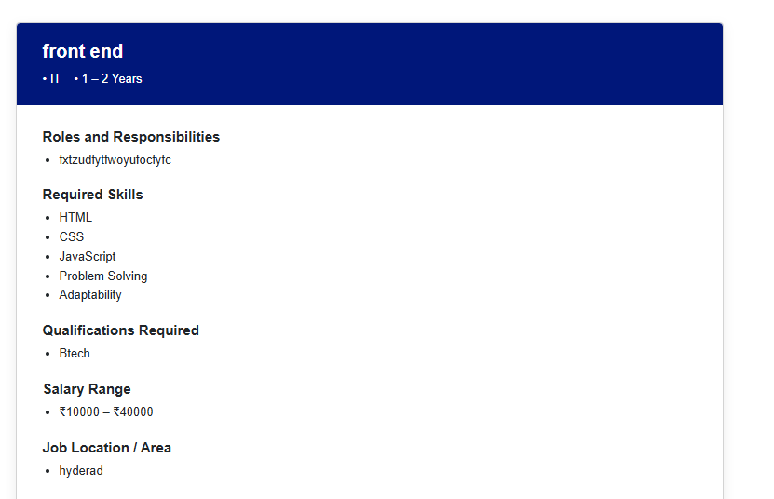
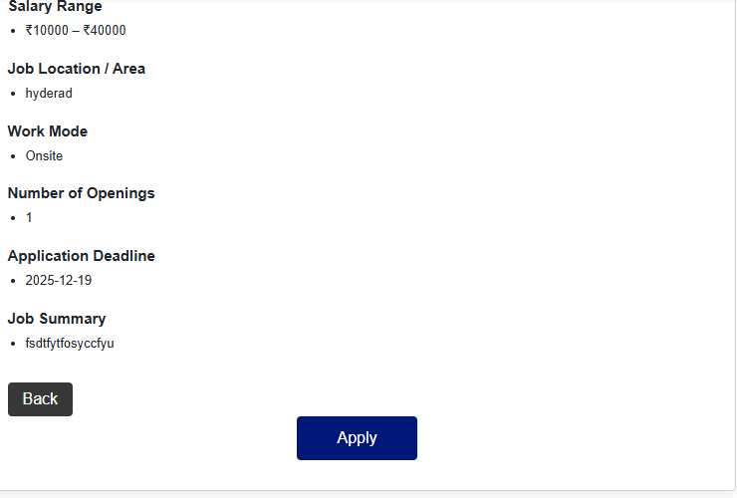
Her whenever I click on the apply button that candidate get the application form
like as
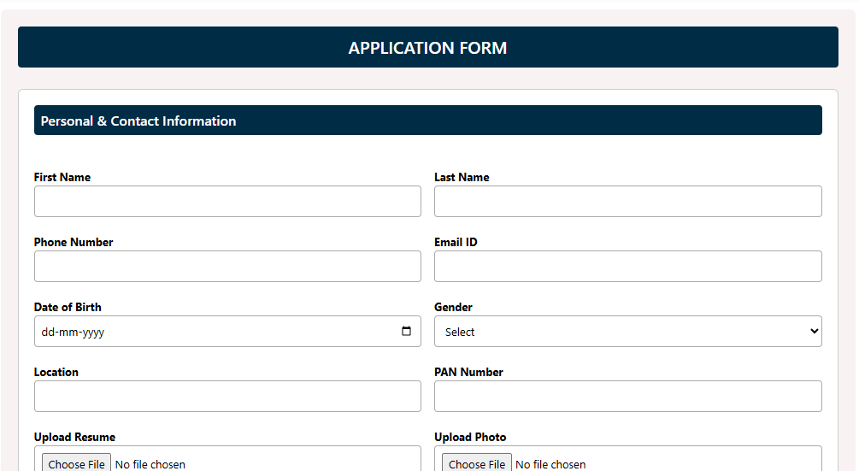
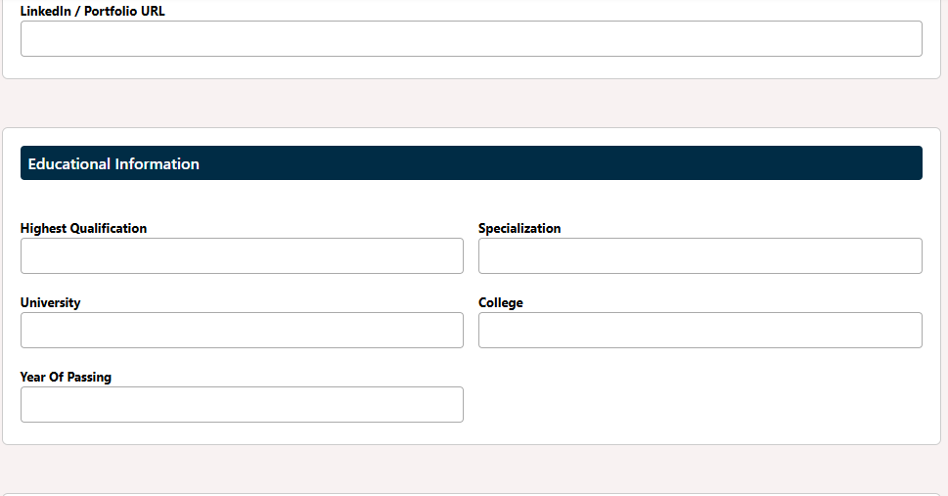
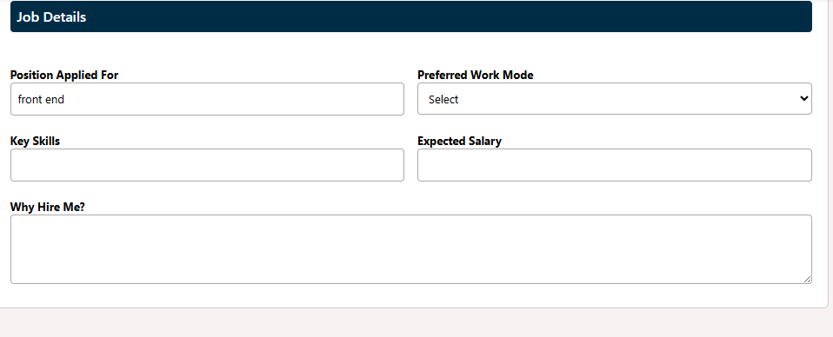
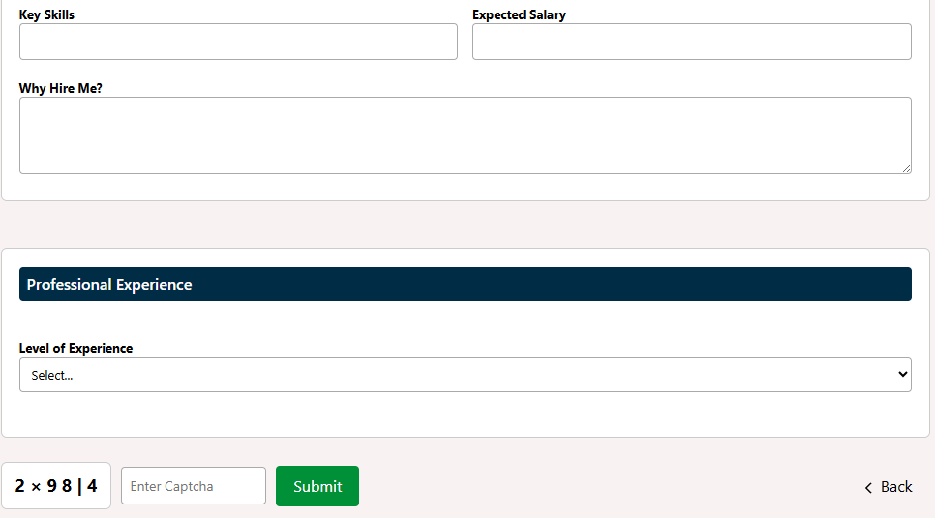

After submit the details that applicant details stored in database and that candidates details visible by the admin. Here we are providing the login for admin and we are created the smaple admin dashboard in that dash board admin can access the get in touch clients and job posting and view the jobs and candidates for applied for the job and admin can check the short list candidates and reject the candidate like that
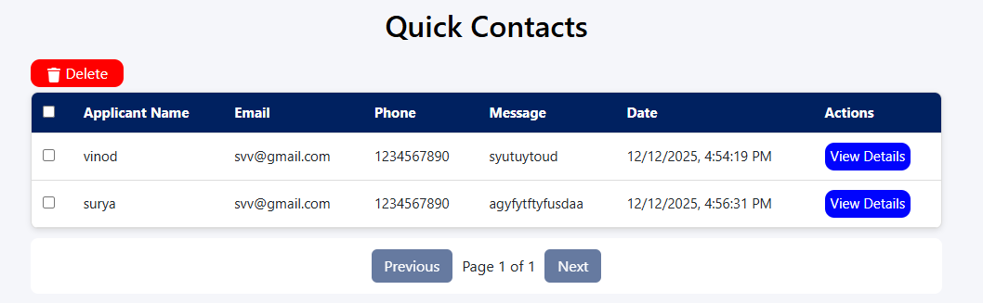 and
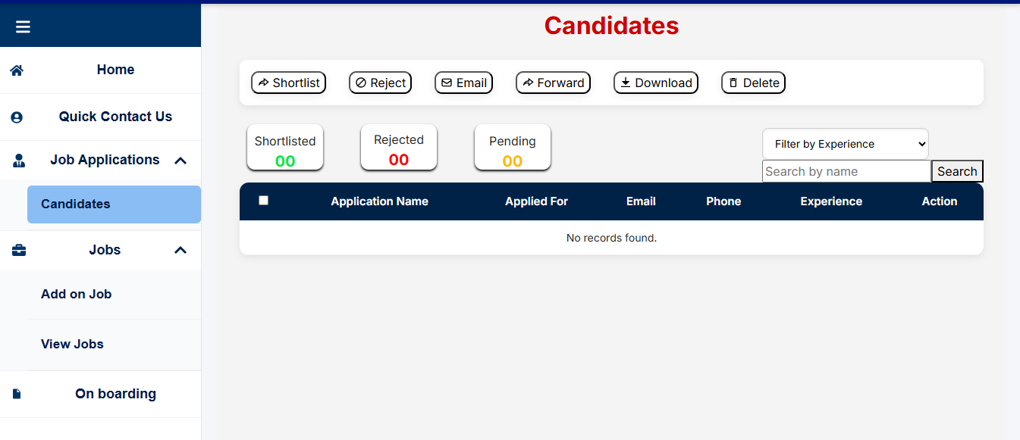
And jobs and job posting and view jobs
